

StudentMania

Discord for students

by

Jack Haugh G00359747

Stephen Gallagher G00314689

Kevin Flanagan G00228079

Mark Campbell Supervisor



May 5, 2021

Final year project

Department of Computer Science and Applied Physics

Galway-Mayo Institute of Technology (GMIT)

Table of Contents

StudentMania 2

Introduction 2

Communication Tools 2

GitHub Repo 2

Ideas 2

Overview of our Project 3

Methodology 3

Research 4

Frontend 4

Linking aws amplify with custom domain – 6

Amplify Table 7

Font awesome Website: 7

Linktree website: 8

Linktree Table 8

Publish.twitter.com - website: 9

Technology Review 11

Key Features 12

Survey 12

Week 9 & 10 15

Week 11 & 12 16

Conclusion 17

Reference 18

Bibliography 18

StudentMania – Communication is the key right now. With the state of the world and what’s happening right now it is more important than ever for students that are working on their education to be able to communicate with one another and with lectures or staff. Taken this into account we decided to create a website where all the students would be able to share notes and be able to communicate and ask questions to do with their workloads. When deciding on our project we were told to try and solve a problem, as students this hit close to home for the three of us.

When students are working from home a lot of different websites are needed (Teams, Discord and Moodle) are just to name a few. It can be difficult for non-computer students to keep track of all these sites. Trying to solve this problem for students and try to help them organize it into one website that could cover all of a student’s needs without them having to navigate and deal with too many sites. Our site will let the user login, ask questions, and have access to chat boxes and chat rooms for students to meet and discuss course work in real time.

## Introduction

### Communication Tools

Given the task to join as a group and come up with a project between us, after meeting with our supervisor Mark Campbell we decided to set up a team’s meeting every week to discuss/plan and work on or project for the coming months.

Before any plans or ideas were decided on were created a mind map for what our project would be, for the goals we wanted to reach and for each other’s parts within the project. We set up meeting with our supervisor and weekly meetings for the group also where would work on the project together so we would all understand what we were creating.

### GitHub Repo

Next up was the creation of a git hub repo where we would all be contributors to the project and work on it individually also as needed. We will also add mark to this repo as our supervisor.

GitHub Repo for the project: <https://github.com/GallagherStephen/4thYearProject-Dissertation>

[PUT GRAPHS FROM GITHUB HERE then remove this!!!]

The main factors we decided on for our project, were “what would be some way to help” and “what do people need”. With this in mind we decided to choose a project that would be a benefit to students as we are currently students ourselves and figured it could be an issue that affects students and their way of learning or living as a student.

### Ideas

Some of the ideas were a “delivery services” for food or other items and a “Lift Sharing” for students that don’t live near the college and need to travel, public transport may not be available to the student.

Car apps and rugby apps were some other ideas we had but decided to final build a student learning app that would store timetables, lab secludes, class notes and have a chat services to let the students communicate with their classmates.

### Overview of our Project

A discord/teams/learn online type website/app would be a great benefit to students and help them keep track of their classes and notes. This app would be designed to be a one stop shop for all a student’s needs online connection with their college and classmates. Communication and friendly interface will be the key to this app/website being useful and successful.

A questionnaire would be something worth thinking about for this project as it would give us some great feedback on what other students outside of the software development course a chance for their voices to be heard when it comes to the design of the app. This app will cater to a wide range of students not only the students that are involved with technically or computer courses.

With the three of us completing this project we will all have to work together as much as possible and communicate on the work that is being completed. With then situation that the word is in now video calls will be our main mode of communication.

Another bit of software we have decided to use was Trello, which is an online managing and note tracking website that all three of us can use to track our progress with designing and building our project. This will let us all work and keep track of our work online that any of the three of us will be able to add tasks or move them to the completed section.

It was our supervisor Mark Campbell that suggested to use Trello as there will be so much going on in the coming weeks that it will be difficult to keep track of all the tasks, Trello allows us to track information and tasking in real time.

## Methodology

Having decided to create a student app for tracking classes and helping the student keep notes and stay in communication with their fellow students in these trying times. Student-mania will provide a platform for students to track and complete their workloads while also helping with time management on projects and lab assignments.

As a fellow student one of the biggest tasks is to keep on top of my workload that I receive every week from lectures, being able to connect with students on discord and lectures on Moodle and having live lab sessions on teams there is a lot of different applications on the go at the same time, it would be far more efficient to perform all this tasks within the same program or application. This would be a hub for students and lectures to use and to display notes from classes, to form a bond with your fellow students and to help one another as you would if you were working in the real world. Student-mania would perform all these tasks cutting down on the overall use of the different applications and have everything a student needs within this one application.

### Research

The student will login and have access to their notes and timetable for there week ahead. All their classes and lab assignments will be displayed, and a forum will be added to allow students to ask their fellow students about any inquires or other questions they may have.

Video conference would be a great feature to have within our application, the ability to talk and see your fellow students goes a long way in helping each other out when it comes to their workloads and will help in the social side of getting to know your peers. Part of college life is interacting with your fellow students and I think a feature allowing video calls would be a big step towards helping students in communicating. At the very least having a chat box that students can use to communicate among themselves.

### Frontend

Research into html and aws amazon.

#### 1st approach (long way):

HTML & CSS files to aws amazon:

When setting up the application to be hosted by aws amazon we had no prior knowledge behind the hosting service. This which had us to doing extensive research into the hosting providers.

We Had to research the following before uploading anything: S3, route53, Ec2. Which we narrowed it down to after looking up what we would need from amazon’s web services.

To begin we researched S3 buckets. After a few posts and videos, we became aware that it is amazon’s way of storing files. Our understanding at the beginning was limited to seeing just files but after doing some more work on it we could see that you could restrict access to these files. We learned that this is used to protect the access of the files which can be retrieved from anywhere on any device through the web if needed.

Below Showing a Diagram which we believe describes the process.

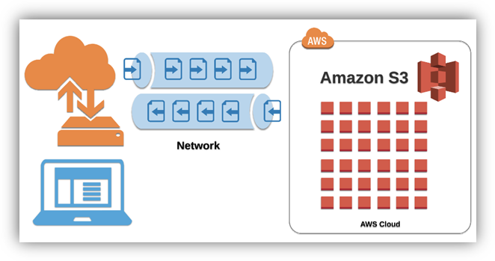

Following this research, we began looking at Route 53, we started to understand that this would be needed for directing the files that would be uploaded. Route 53 being amazons widely available and scalable cloud domain name system (DNS) service. From this we learned how it helps host your files to the web for the public to see on any browser worldwide.

**NEXT TO EXPLAIN:**

* Two issues as was not able to see website after uploading all the files:

Permissions tab in the s3 bucket– make files static to be able seen on web.

Also, must unblock public access to allow public to see website.

* Route53
* Record A being for an alias which connects the bucket with html files to the URL
* Record (SOA) and name of server (NS) being provided by amazon
* CNAME setup when directing the bucket to the new [www.student-mania.com](http://www.student-mania.com) domain

#### 2nd approach (short way):

HTML & CSS & JavaScript & react to amazon aws:

## 

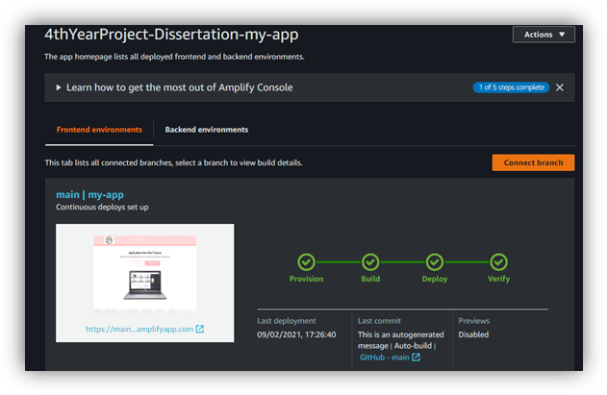

Uploading to amplify we discovered that we can only host the application to amplify if we were the admin holder of the repository of the project. We soon uploaded the project to amplify but came across some issues. Here where we wanted to be able to contact customer support but due to them removing the live chat functionality unless you pay for a plan, we were unable to access. We then had to research why we were getting the error “page cannot be found error 404”. We knew to be a linking issue as it was there but couldn’t be located. After extensive research we didn’t find the solution, we found that this was not covered enough within online forums or any of our other research, which produced no results.

The solution we found was that when you are uploading to aws amplify and linking your repository to it you must click on the small box at the end that allows the admin to specify the exact folder of the application within your repository folder. This is not covered or explain to be “needed”. When we were going through the process, we thought this was an extra feature, but between trial and error we figured that this feature needs to be ticked to declare the primary “my-App”. We also put two and two together as when we were researching, we came across that when you are uploading the repo to amplify that when amplify discovers your app it looks for your “package. JSON” file. This then tells amplify all the commands that are needed to build the application.

Once we got round the issue of error 404, we had the application hosted by aws amplify as seen running through the deploying stage of amplify.

During the 2nd way that we were trying it was unfortunate that amazon started to set up plans for users to have to pay for help off customer service if you wanted help in other ways than live chat. This feature which we used at the end of the first way of going about uploading the application website to aws amazon. As after we uploaded everything, we were still unable to see the website but on live chat we were helped out within minutes. Being explained to us that it could take up to 48hrs to fully upload and be visible on the web with the URL they provide.

### Linking aws amplify with custom domain –

In our learning and researching of linking your domain to amplify we learned that when you setup a route53 it provides you with the four name servers and SOA .But when you go to your “Domain management” on your aws amplify and select the route53 you setup to link the two it generates the “CNAME” and “ALIAS(A)” for you. This which had to be done manually when not using aws amplify.

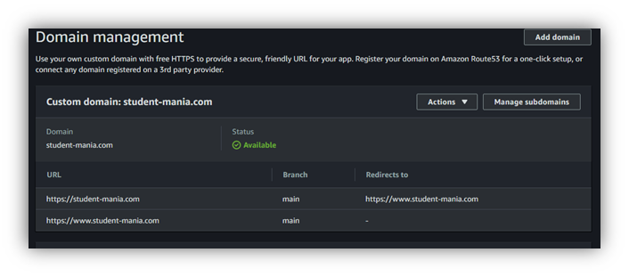

Since we have done this both ways, we know what amplify does for its users, so they don’t have to setup everything themselves which can make setup very convenient for users.

In the process of adding our custom servers to our GoDaddy domain we ran into an error when we clicked the save button. This error which was “an unexpected error”. When we looked up this error it came back to be a common error. This suggested to access it on an incognito window or clear the user’s cache. This which did not work for us and we ended up having to contact customer service via live chat.

We were extremely happy to hear they had live chat but unfortunately the customer service person did not provide us with a reason behind the error. The only solution was that he entered the name servers into the account for us and save it then. We found this to be very strange but decided to try the same thing again but under a different name but got the same results and got the same error. After all the issues by the end of the day we were happy to say we got the website up and running and searchable through google for the second time using a different approach.

Amplify is very useful when making changes to your application as you don’t need to reupload your files to your s3 bucket to update your online application. It simply automatically rebuilds your application when you make a change/commit to your linked GitHub repository. This which saves time and helps in faster development of applications.

## 

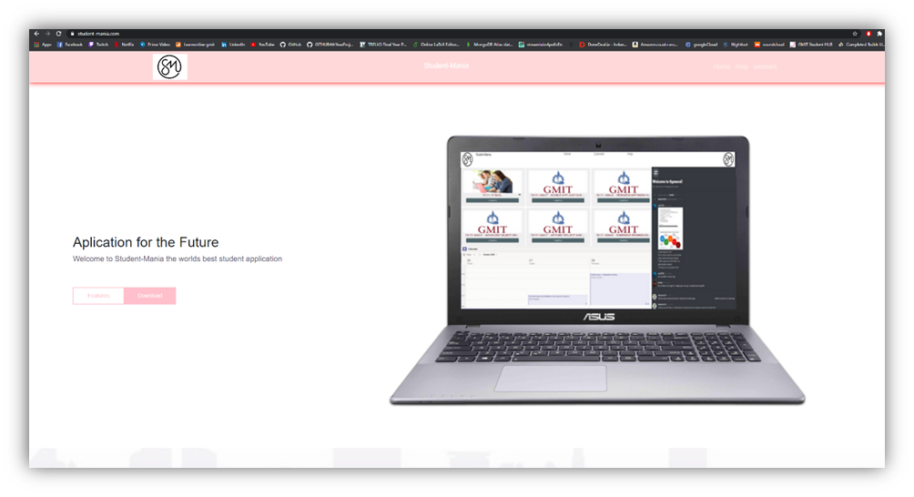

### 

### Amplify Table

|  |  |
| --- | --- |
| **Pros:** | **Cons:** |
| Updates online App when you commit to GitHub | If Errors in code wont build. |
| Don’t have to do the linking between files and servers, does it for you |  |
| Makes you app public by default |  |
| Can add tests to application when uploading if you wished for in the build process |  |

### Font awesome Website:

We used Font Awesome website to get icons that we could use to link our social media accounts to our website for advertising and easy access. This makes navigation between the social media accounts easier for the users.

To use these icons on our website we had to make an account that provided us with html code that we had to have embedded in our code to allow the icons to appear.

This after having imbedded in the body of my code allowed us to search for icons on the website. There we selected the one we wanted, and it then provided us with more html that we simply had to paste into our application where we wanted it to be displayed. Here where we embedded this html code from the website into a href tag that allowed us to reference a website when a user clicks on the icon. This we repeated for each social media account that we wanted to reference.

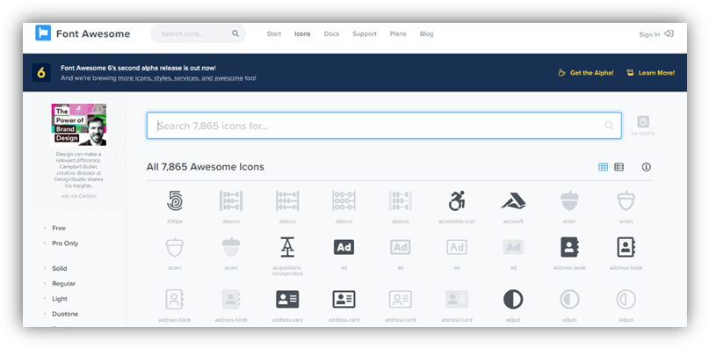

### Linktree website:

This website I signed up to for it to allow me to link multiple websites to the one account. This which makes it easier to list to the users the accounts all in one place neatly. I had to sign up using my college email and verify the email. Here I created the account under the username of the application called Student mania. This which I thought was a good idea for later expansion when multiple websites will be created for marketing purposes. Added this to the website to show its purpose and its workings.

### Linktree Table

|  |  |
| --- | --- |
| **Pros:** | **Cons:** |
| Allows expansion | Have to setup another account |
| Neat layout |  |
| Less icons on website to be displayed |  |

### 

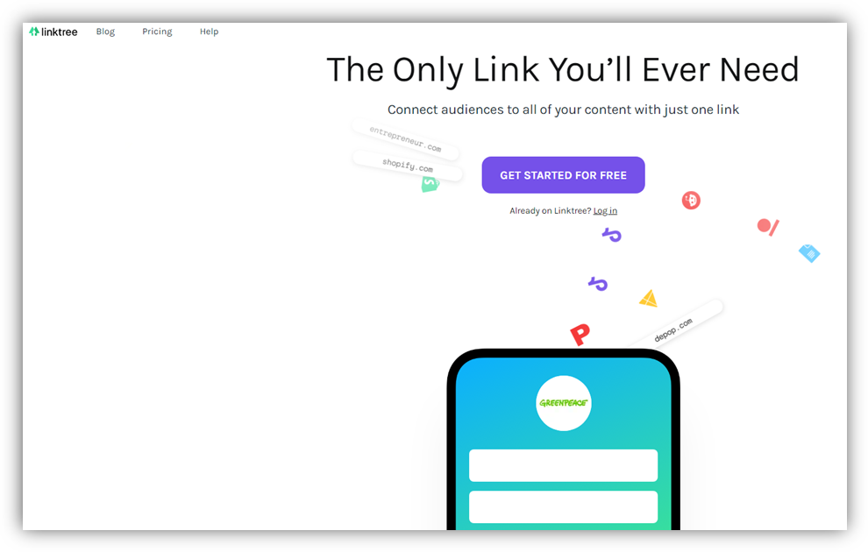

### Publish.twitter.com - website:

This website which allows you to enter the twitter account of your choosing and be provided with the embedded html code to paste into your website. This code that displays the twitter feed from the twitter account chosen.

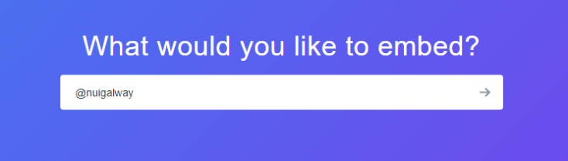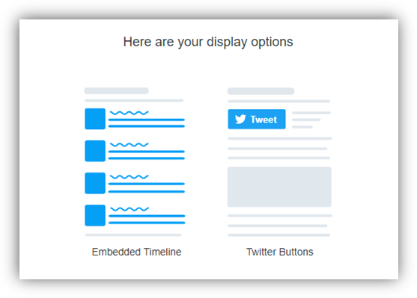

After you select the account you can chose which way you would like to display the account feed on your website with two options. **(1)** Embedded Timeline or **(2)** twitter buttons.

Then you can customize the feed to your liking. This which can be size, width or even colour.

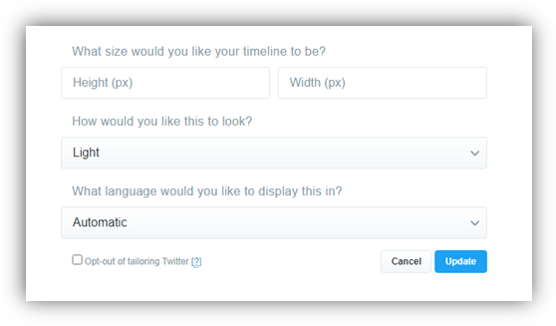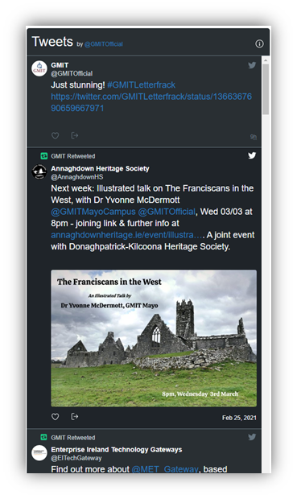

Here you can see the outcome after some custom inputs were chosen.

This which wouldn’t display correctly when added to the html as it was a react application. This which required the following.

1. To install the dependencies for the twitter feed to display in a react app

npm install --save react-twitter-embed

1. To import these dependencies to the html

**import** { TwitterTimelineEmbed, TwitterShareButton, TwitterFollowButton, TwitterHashtagButton, TwitterMentionButton, TwitterTweetEmbed, TwitterMomentShare, TwitterDMButton, TwitterVideoEmbed, TwitterOnAirButton } **from** 'react-twitter-embed';

1. To add the following tag to display the feed on the page

<TwitterTimelineEmbed/>

This which allowed me to display multiple twitter feeds on the application.

## 

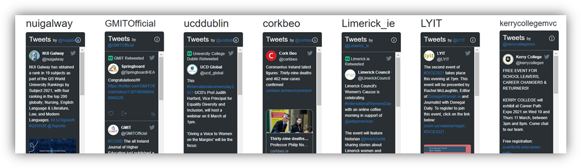

## Technology Review

Having decided on our project we have had a few meetings at this stage with our supervisor and have decided on breaking up the project between the three of us:

Jack – WEBRTC the back end of the project and will use real time media communications. E.g. HTML5

Kevin – MongoDB setting up a database to allow information to be stored. E.g. Login details

Stephen – Frontend the user interface that will be displayed on our site. E.g. CSS files

***WEBRTC*** will enable us to use audio, video and share data communication between browsers without having to use any plugins. This will allow us to simplify communications on our website and will also improve the users experience while they are login into our website. After becoming available in 2011 WebRTC has only grown in popularity with an estimated 2 billion browsers that are enabled to use WebRTC. WebRTC is an open source project that can be customised as the developer needs it is also completely free to use and is constantly evolving and improving over the years.

***ZOOM*** and ***NETFLIX*** are only two of some of the biggest names in the industry that use WebRTC to help improve their products.

***MongoDB*** is the leading NoSQL database that is currently available on the market now and uses a document-oriented database. Large or small datasets are supported by rich query’s with fast response times and enables agile development using dynamic schemas and flexibility for requirement changes as the developer sees fit.

Using ***MongoDB*** gives us scalability, performance, and high availability that other databases would not be able to handle. MongoDB is already a proven solution for all business requirements to companies on a global scale. MongoDB uses a collection of documents, each of these documents include key/value attributes, a document is seen as a row in a table, with each key used as a column name and each keys value is like the rows value. The different is that a document is not constrained to be a certain schema or a column within the table. These documents may share similar elements such as ID fields and having different elements within the document. An example if this would be a garage and a shop, they both could have ID fields but then differ afterwards.

### Key Features

**Flexibility** - MongoDB was designed to work with cloud platforms and commodity hardware, data is then localized for queries that will ensure performance is at its peak no matter the deployment size of the project.

**Scale-Out –** MongoDB has been designed to be scaled across server clusters, when the data starts to grow, the user can add more nodes to the clusters and MongoDB will balance the data among the clusters evenly and automatically in the background.

**Dynamic Schemas** – This lets developers make changes that are required in the system without affecting the existing data already stored in the dataset, not incurring any downtime. With other schemas they must be defined before data is inserted. With MongoDB the schema is dynamic this allows it to be scaled as needed and supports fluent polymorphism.

**Rich Querying** – MongoDB uses a full query language; a primary and secondary indexing is also used and a Google like text search.

MongoDB is the perfect database to use within our project, with its flexibility, scalability and high performance using dynamic schemas this is perfect for our project. MongoDB is a document-oriented database that will allow us to store JSON documents with a dynamic schema that we will use to store our records/logins and will scale up as we need and also allow us to add or remove field and types as needed to our project. No other NoSQL or relational database software makes it as easy to use and to develop databases.

### Survey

As a group we have decided to produce two different surveys to get feedback on the project and get an idea for what would be needed to keep our platform up to date, useful and the right tool for students to use to communicate with their fellow students. “*Survey Monkey”* was our first choice but after researching into it, we discovered that there was a limit to the amount of responses that we could receive before paying a fee for this we decided to migrate over to Google forms. With no limits we were free to conduct as many surveys as we needed to use as we saw fit.

For our surveys we researched different survey forms and example type questions that we could modify to get the best survey responses from our potential future users.

This consisted on different type questions like the following:

• Open-ended questions • Likert scale questions

• Multiple choice questions • Demographic questions

• Picture choice questions • Closed-ended questions

• Rating questions

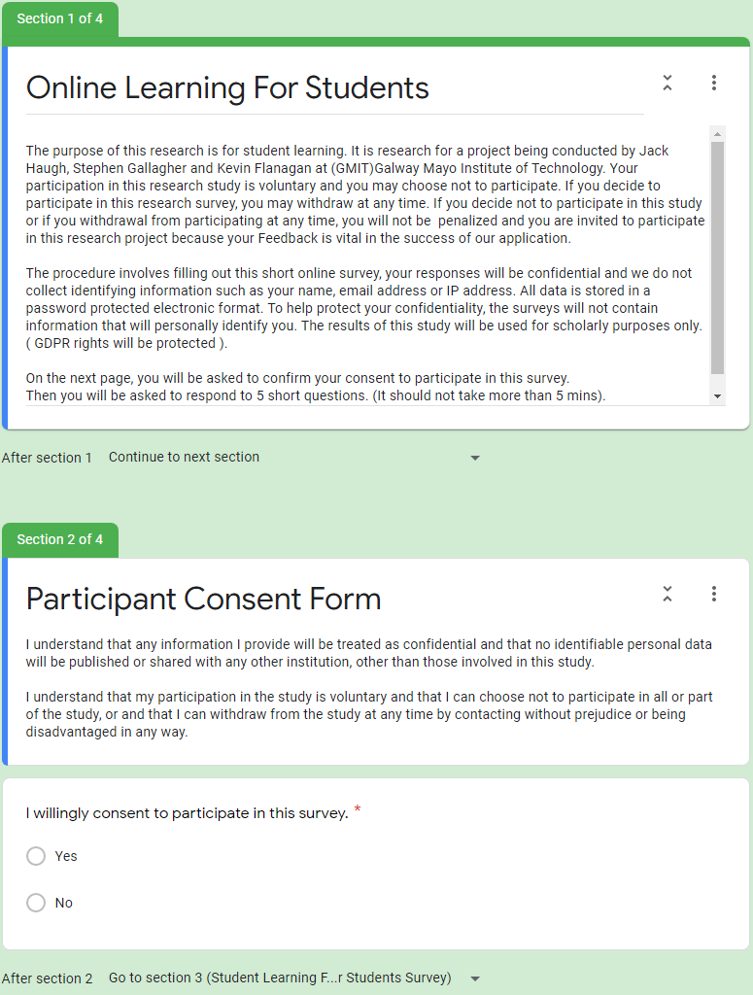

Working on Google forms we will create these surveys and send them out to our fellow peers and see what feedback we can get. This feedback will hopefully lead us down paths that we wouldn’t have thought of ourselves and give us some insight into what people would like to have implemented into our website.

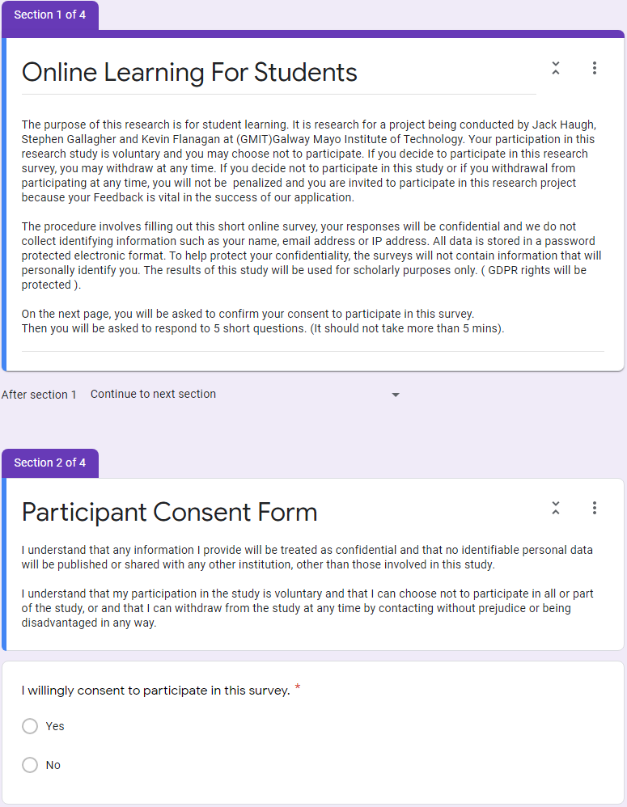

After deciding what we were going to ask (Questions below) students what features and what applications that they would like to see included and what would be helpful to their learning. Based on feedback we will be deciding on what we should be creating in our platform.

We set up the two surveys on Google Forms, where we created a quick survey to gather information from students and other users with about 10 questions and some terms and conditions for the user to agree too. With this information we plan on adding or deleting different functions within our website and will give us an idea of what other students are looking for. The goal of this first survey is to hopefully come across an idea or function that we failed to see ourselves and if possible, to implement said function into our own site. The first survey we decided to email it to our peers and students in other courses to see what their responses would be to our survey.

Example of questions we used in our two surveys:

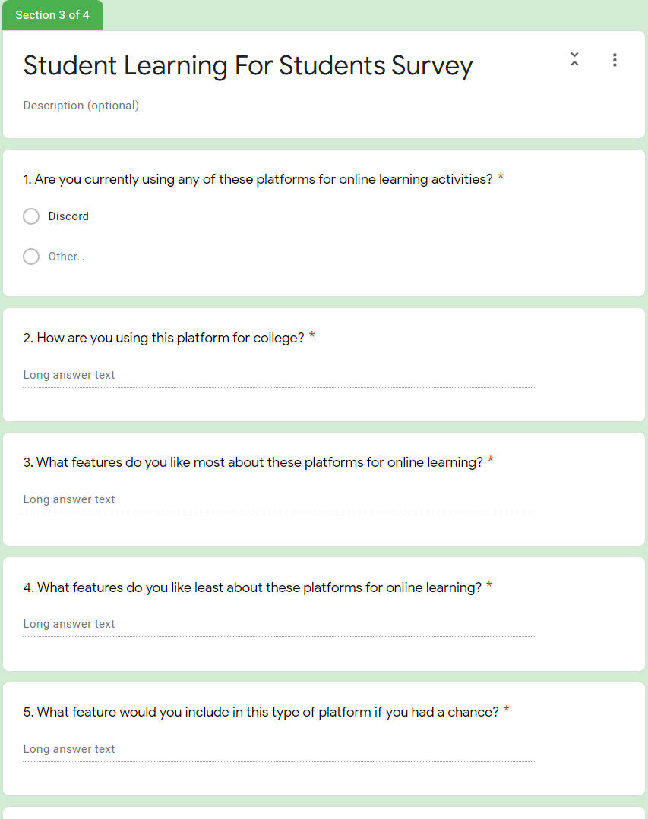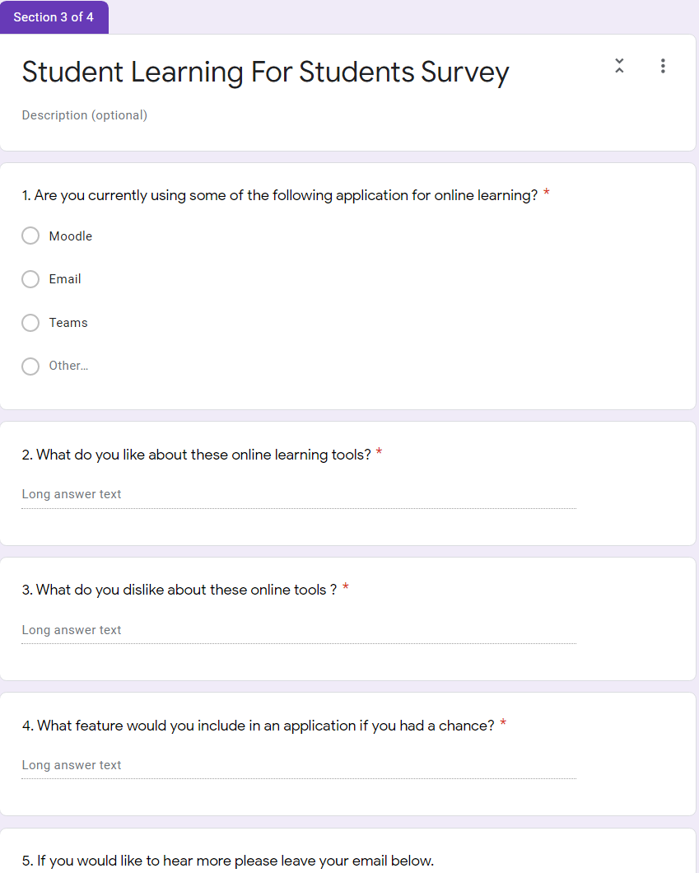

The second survey we decided to be more specific in our questions, this will let us narrow down the possible results and answers that we receive back from the participants of the survey. Again, we are hoping to get that one bit of information or idea that we never thought of ourselves. For this survey we only needed 5 questions and they were aimed towards Discord which is a VoIP, instant messaging and a digital distribution website/app, from our first survey we discovered that this seemed to be the main way that students were communicating outside of college websites such as “Moodle”. This information let us narrow down the questions (5) we asked in our second survey and got a better view of what students wanted from this type of website/app.

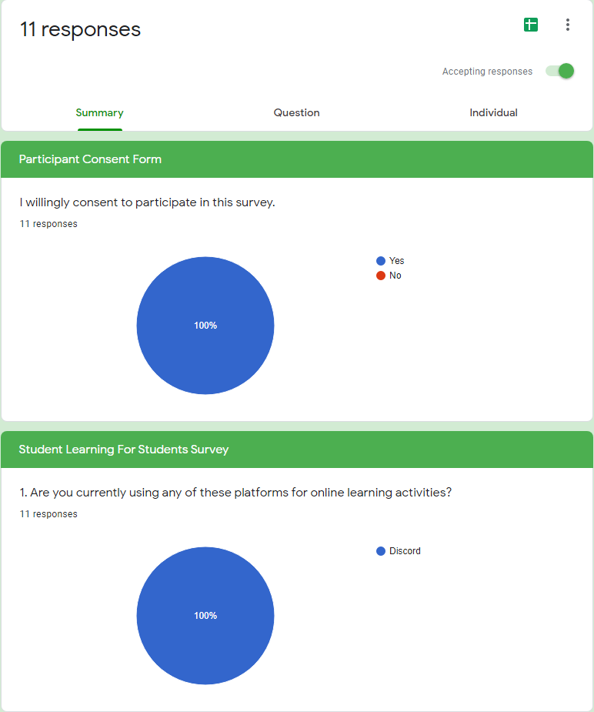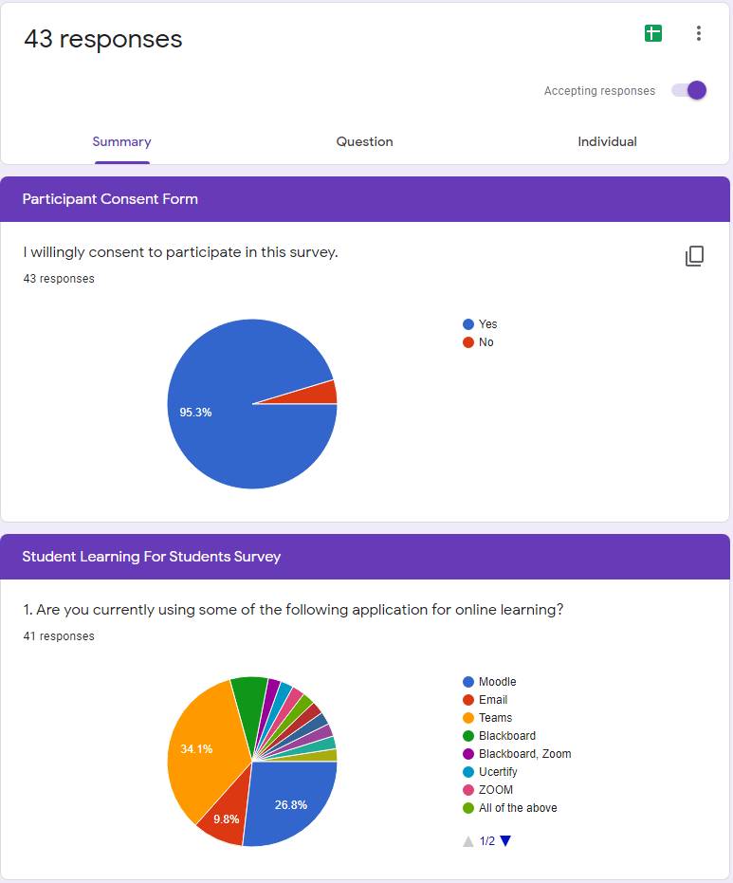

With some great data gathered from the surveys from Google Forms we have a good idea what is expected in this type of website/app. From this information we hope to achieve a website/app that our fellow students would not only be happy to use be would also be helpful in their college workloads.

### Databases

The front-end has been created with a great display and very user friendly. We plan on having our website running global and have our databases and servers running with a GoDaddy domain letting it be accessed from anywhere. The next biggest step is to set-up MongoDB to be our database for the website to store details and secure logins. This will allow students to share documents and notes from lectures and classes, forums to ask questions, timetable to track classes and labs.

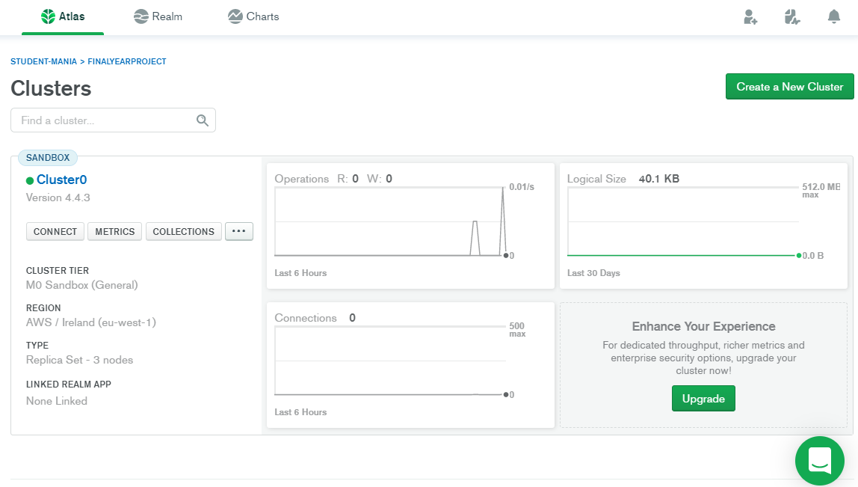

MongoDB is an object-oriented, dynamic and a scalable NoSQL database that stores information in data objects. These data objects are then stored as separate documents inside of a collection. These collections are created by the user and then a cluster is created within the collection.

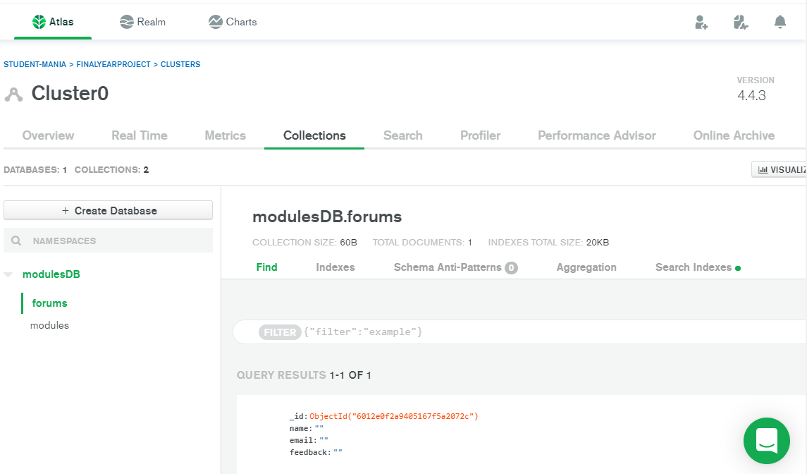

From the image above we had to connect the cluster to our application which involved a line of code, that would allow our website/app to connect to the database to write and share information while also saving it to the database to be recalled when server is running. To allow mongoDB to receive information from the website/app while also returning the information when called upon in the future we created a database called modulesDB which had collections that will store information that is desired for the different sections of our website/app. We then created different classes within our directory that “talked” to each other to send and receive information. This information is needed firstly to receive the information from the user and then secondly to return that information to be displayed for all users to be seen on our website/app.

### Database/elastic beanstalk issues

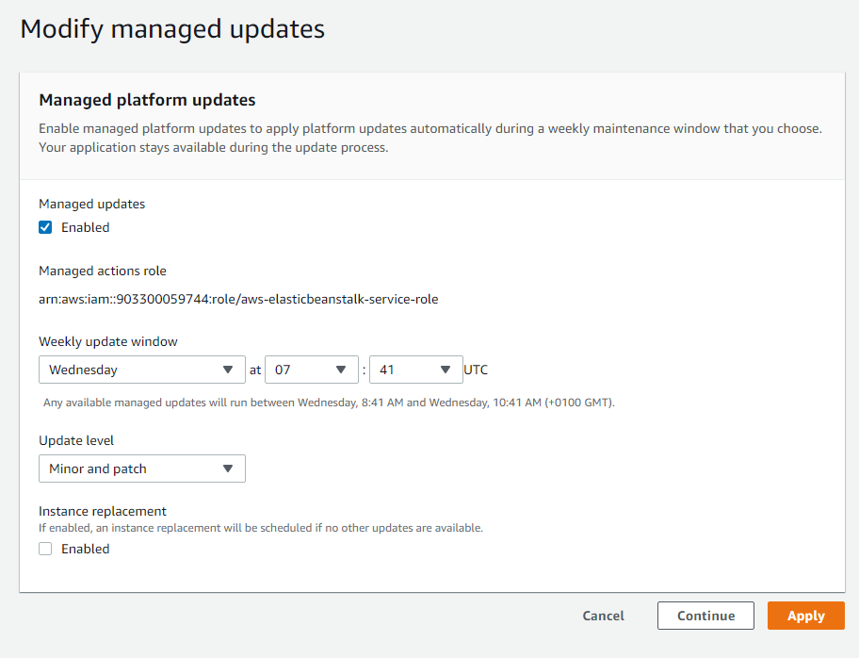

On elastic beanstalk you can enable auto updates. This option which allows you to pick a time and day each week that automatically updates your platform/application.



This can be found under configuration at the bottom few options.

**ERROR WITH INSTANCES:**

Looking into issue below:

Site : <https://aws.amazon.com/premiumsupport/knowledge-center/elastic-beanstalk-instance-failure/>

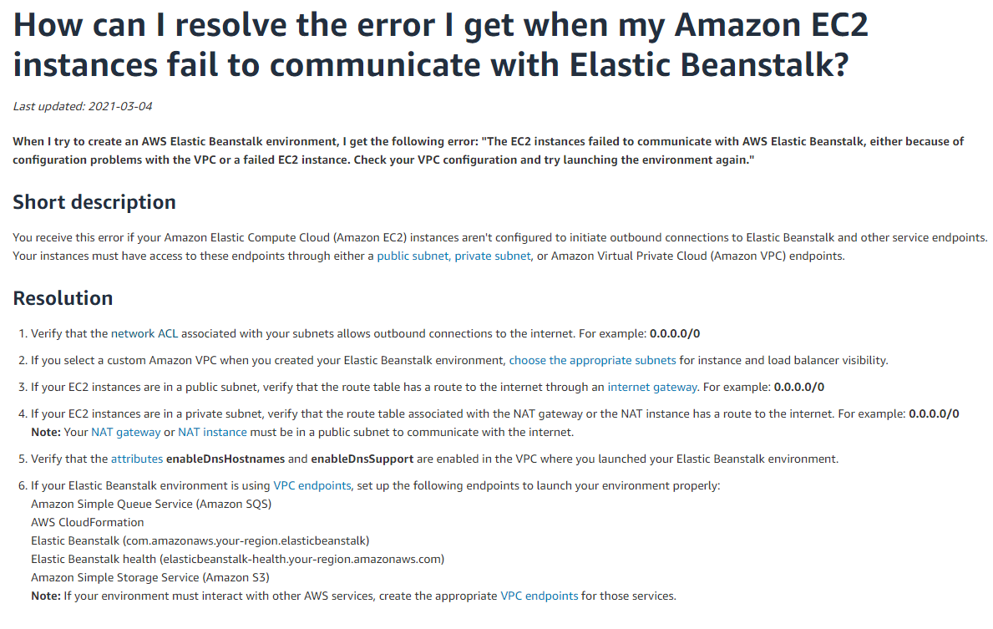

based on the list above I tried going through each section and trying to narrow down the issue.

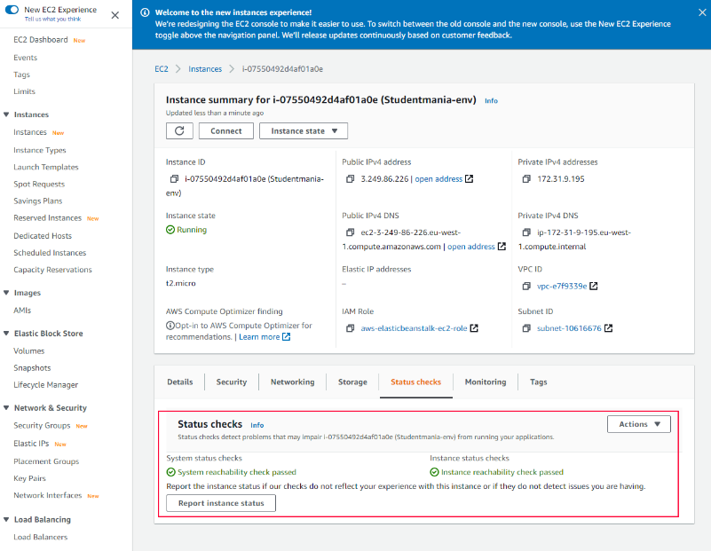

Started with checking is the instance running ok in general.

Noticed there was no Elastic Ip addresses assigned which made me look into it , to see if it was required for the traffic .

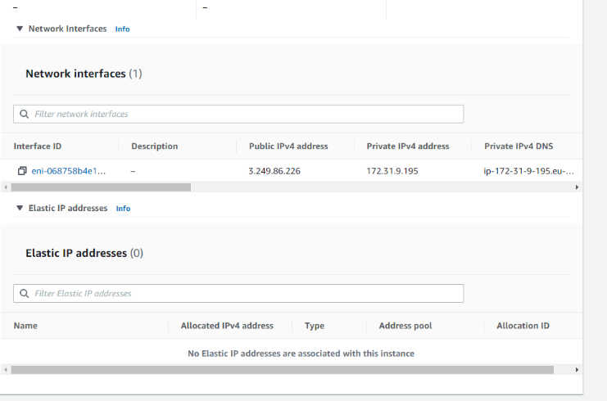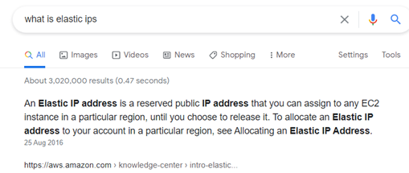

Started looking into VPC which is a Virtual Private cloud that allows you to control who has access to your AWS resources, because I noticed on the following website:

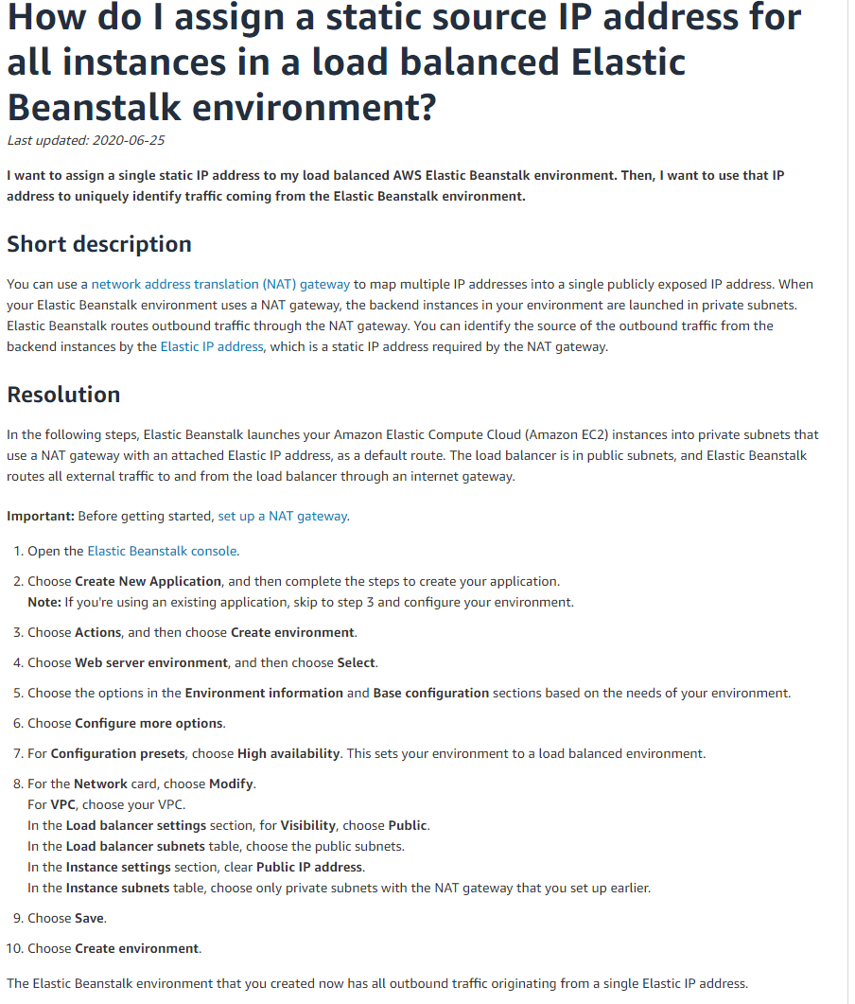

<https://aws.amazon.com/premiumsupport/knowledge-center/elastic-beanstalk-static-IP-address/> when setting up the environment on AWS you have the option to select VPC or load balancer which can balance the load for you and allow you to add extra instances but you can make the visibility public. As seen in image below

I also took to youtube for more of an insight to VPC on AWS.

Also took note that our Network on our environment was not part of a VPC

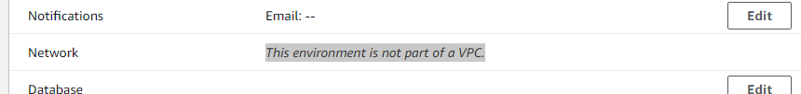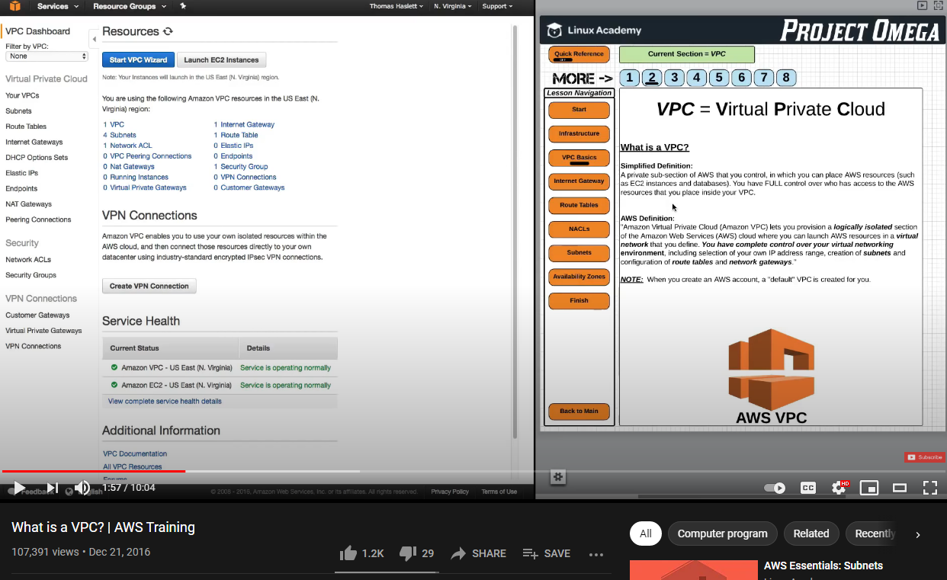

Looked online for videos etc and came across the way in which to find the load balancers IP addresses. These addresses I added to MongoDB to see was it an access problem.

<https://www.youtube.com/watch?v=PKjbuxnispM&ab_channel=Academind>

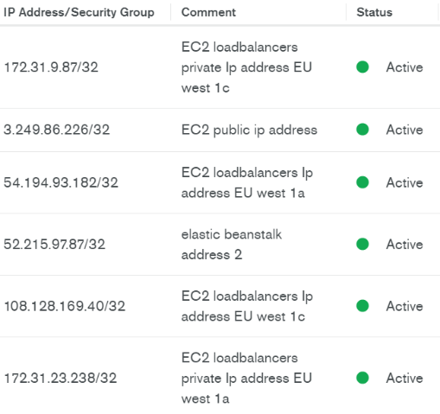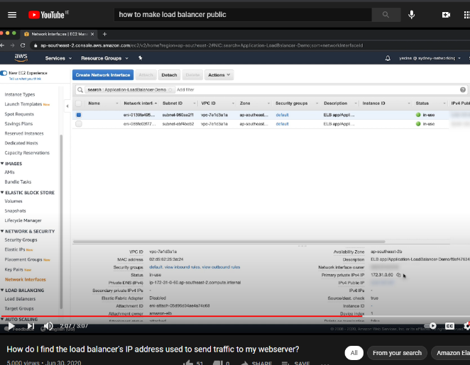

Looked up a video and it started to walk me through elastic beanstalk and linking the domain with the database through HTTPS. Which I believe to be for security reasons.

Video link : <https://www.youtube.com/watch?v=BeOKTpFsuvk&ab_channel=WornOffKeys>

Requesting certificate for domain:

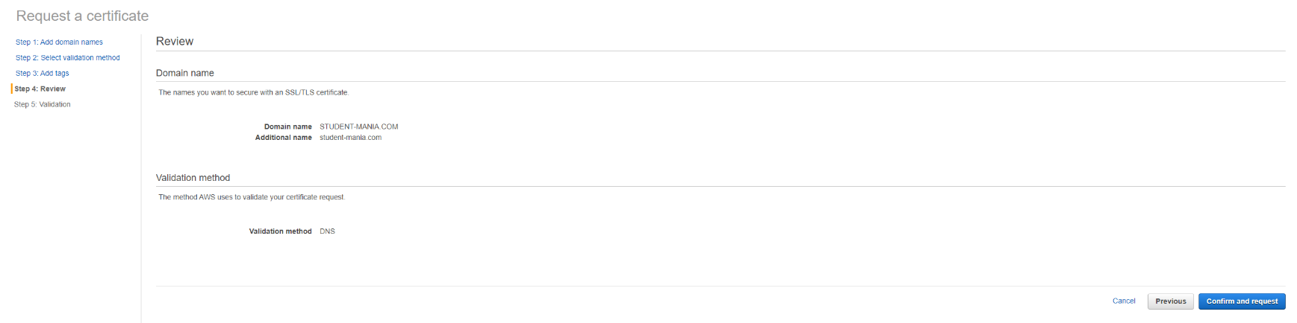

request in progress:

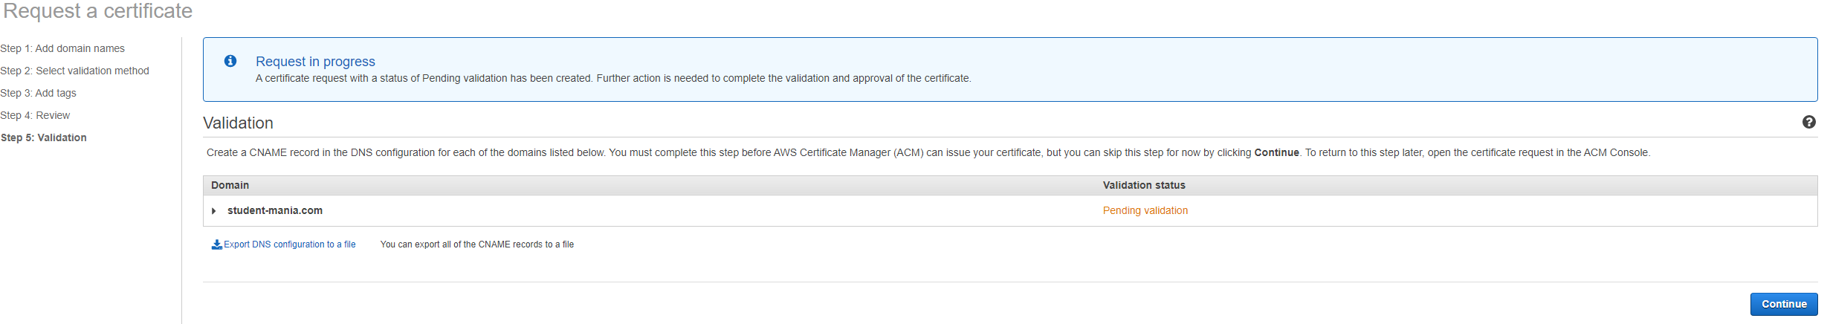

looked up how long it will take:

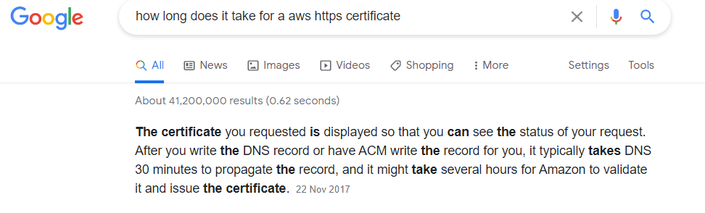

## Week 11 & 12

## Conclusion

Communication is key.

## Reference

<https://www.typeform.com/surveys/question-types/> Survey Research carried out

<https://ie.godaddy.com/> GoDaddy

<https://www.mongodb.com/> MongoDB

<https://www.google.com/forms/about/> Google Forms

<https://aws.amazon.com/amplify/> AWS Amplify

<https://aws.amazon.com/elasticbeanstalk/> Elastic Beanstalk

<https://learnonline.gmit.ie/> Learn Online “Moodle”

<https://discord.com/> Discord

<https://trello.com/> Trello

<https://www.surveymonkey.com/> Survey Monkey

<https://linktr.ee/> Linktree

<https://www.youtube.com/> YouTube

<https://www.instagram.com/student.mania/> Instagram

<https://www.facebook.com/Student-mania-108833497918996> Facebook

[https://publish.twitter.com/#](https://publish.twitter.com/) Twitter

<https://fontawesome.com/> Font Awesome Icons

<https://reports.internic.net/cgi/whois?whois_nic=student-mania.com&type=domain> Name Domain Server Check

<https://www.overleaf.com/> Overleaf

## Bibliography